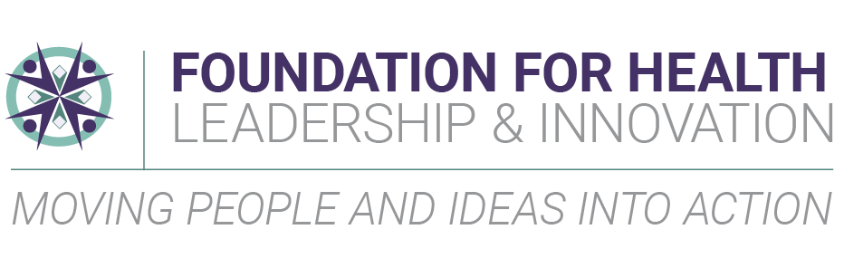
POSITION ANNOUNCEMENT: President and CEO, Foundation for Health Leadership & Innovation
LOCATED IN: Cary, North Carolina

BACKGROUND
Launched in 1982 under the leadership and vision of James D. Bernstein, the Foundation for Health Leadership & Innovation (FHLI) is a nonprofit organization that envisions healthy communities across North Carolina where everyone can flourish. FHLI develops and supports innovative programs and partnerships that advance affordable and sustainable quality health services that improve the overall health of communities in North Carolina and beyond.
With a long history in the state — and a deep understanding of its health care needs — FHLI helps develop and scale solutions that benefit the entire state and its diverse communities. FHLI staff are thought leaders and experts who bring communities together for a better, healthier North Carolina. Current program initiatives include:
- The Center of Excellence for Integrated Care assists health systems integrate physical and behavioral health care services
- Health ENC collaborates with health departments and hospitals in eastern North Carolina to facilitate community health needs assessment, as well as build partnerships to address health priorities identified through the assessment process
- NCCARE360 is the first statewide network that connects healthcare and human services with a shared technology that enables a coordinated, community-oriented, person-centered approach to healthcare
- The NC Oral Health Collaborative brings partners together to improve the oral health status of all North Carolinians
- The NC Rural Health Leadership Alliance supports partnerships and strategies that improve health outcomes in rural North Carolina
- Practice Sights uses retention software and strategies to help retain healthcare providers in rural areas
- Rural Forward North Carolina program amplifies the impact of rural leaders, organizations, and coalitions through capacity-building and resource development
- The Jim Bernstein Community Health Leadership Fellows Program develops future leaders to work in, and improve the health status of, rural and under-served communities in North Carolina
- The Jim & Sue Bernstein Health Center Scholarship Program provides scholarships each year to employees who work at rural health clinics in the state and their qualifying family members
Operating on a $4M budget, FHLI is primarily funded by grants, with additional support from the business and civic community. The team consists of 20+ staff members and 17 board members, with additional support from advisors, coalitions, and volunteers. To learn more, visit FHLI’s website at https://foundationhli.org/.

THE LEADERSHIP OPPORTUNITY
Reporting to the Board of Directors, the President and CEO is the senior executive at FHLI and primary spokesperson and advocate for its mission. The President and CEO leads the organization in developing the strategy, funding, culture, and relationships necessary to maintain FHLI as a respected leader and convenor. The board seeks a visionary, strategic professional with proven leadership expertise, an understanding of how social determinants of health impact healthcare, first-hand knowledge of health barriers impacting rural communities, and a commitment to equity, diversity, and inclusion.
The President and CEO must possess outstanding interpersonal skills, be comfortable working with people of wide-ranging backgrounds, a successful communicator and listener who assesses and responds to the needs of the community, board, staff, and key stakeholders. They must keep a focus on the long-term objectives of the organization while balancing strategic responsibilities. The President and CEO will be called upon to fulfil the following key responsibilities:
Leadership and Innovation
- Drives a consistent, state-wide conversation focused on overall health that explores ways to improve health outcomes for North Carolinians.
- Partners with the board, staff, and stakeholders to define the strategic course for the organization’s future.
- Articulates the vision in an inspiring way to internal and external constituencies.
- Works with community, state, and national agencies to clarify health needs, establish effective partnerships, and pilot programs that improve the quality and broaden access to health care.
- Develops, advocates, and monitors state-wide health initiatives to improve health at the local level.
- Identifies and monitors trends and emerging issues related to rural communities, health, equity, and leadership moving beyond healthcare access to health care systems transformation and systems change.
- Builds authentic relationships with strategic partners and key stakeholders on behalf of FHLI while actively listening and receiving input from diverse viewpoints.
- Fosters innovation by balancing accountability with creative freedom.
- Demonstrates a commitment to advancing diversity, equality, and inclusion internally and externally.
Strategic and Financial Oversight
- Ensures high-quality program delivery, evaluation, and reporting that promotes the effective utilization of personnel and financial resources.
- Provides insight for expanding, developing, or modifying programs and services as it relates to the strategic plan leveraging the thought leadership of staff.
- Ensures strong internal control, fiscal responsibility, accountability, transparency, and efficient, accurate, and consistent financial operations and practices.
- Promotes the highest level of integrity with respect to fiduciary responsibilities and organizational policy.
- Works with finance staff to develop an annual budget for the board’s review and approval.

Resource Development
- Responsible for the consistent flow of revenue to the organization, including public/private partnerships, grants, philanthropic giving, and fundraising activities through diverse and multi-faceted income streams.
- Serves as the chief development officer for the organization. Works in partnership with staff to build multi-dimensional relationships with funders.
- Leads fundraising efforts, including the board’s involvement in fundraising, personally cultivating, and soliciting donors, as well as developing sustainable funding for the organization.
- Builds a pipeline of donors with shared vision and values to achieve collective impact.
- Cultivates positive and sustained relationships with local, state, and federal funders and foundations, corporations, and other major funding partners.
- Develops and implements a plan to expand relationships and partnerships that will lead to sustainable, diversified funding streams and significant philanthropic investments.
Staff Development & Empowerment
- Develops a strong management team and staff, empowering individuals to fulfill their highest potential.
- Fosters a positive culture of teamwork and accountability throughout the organization that supports a risk-taking, collaborative work environment that is open to new ideas.
- Maintains a positive and healthy workplace culture that attracts, retains, and motivates high-quality employees and volunteers.
- Ensures the organization has a diverse staff with skills appropriate to the needs of their positions through people management activities, including hiring, separation of employment, ongoing staff development, performance management, compensation, and benefits.
Board Development
- Works collaboratively with the Board of Directors to support a strong model of governance and engages with the board as appropriate on issues related to strategy, mission, vision, values, reputation, communications, community impact, and state or national collaborations.
- Maintains a strong working relationship with the board, ensuring the necessary staff support for effective governance.
- Ensures a quality process for identifying, recruiting, orienting, retaining, and celebrating board members.
- Provides board committees with the necessary support, counsel, and information required for effective board governance.
SKILLS AND QUALIFICATIONS
The new leader must demonstrate a passion for improving the overall health of North Carolina’s communities. In addition, the ideal candidate will possess the following qualifications:
- Ten or more years of experience as a senior executive of a complex organization where sustainability and growth were integral to success
- Bachelor’s degree or higher from an accredited college/university
- Strong interpersonal and deep relational skills, with the ability to build trust, respect, and consensus among a diverse group and interact equally well with the board, staff, and community leaders
- Excel in navigating complex group dynamics and be comfortable as a conflict mediator
- Demonstrated fundraising experience with success in building dynamic relationships with key stakeholders who can influence individual, corporate, and foundation giving; experience cultivating, soliciting, and stewarding major gifts; grant experience preferred
- Knowledge of public health, health care systems, and health equity
- Experience in CQI and documenting outcomes
- Familiarity with rural communities
- Demonstrated history of the sound judgment, administrative skill, and financial acumen necessary to oversee day-to-day operations, direct staff, and manage a budget of at least $4 million
- Strong sense of urgency and natural curiosity
- Commitment to mentorship and leadership development
- Understanding of NC healthcare and politics preferred

SALARY AND BENEFITS
This is a full-time, exempt position. Salary is commensurate with experience. Benefits include health, dental, life and disability insurance, a matching retirement plan, 15 paid holidays, vacation and sick leave, flexible spending account, and phone stipend.
APPLICATION PROCESS
Armstrong McGuire & Associates, based in Raleigh, NC, is conducting this search in partnership with FHLI’s Board of Directors. To apply, click on the link to the President and CEO – Foundation of Health Leadership & Innovation position profile at ArmstrongMcGuire.com/apply. You will see instructions for uploading a cover letter, resume, salary requirements, and professional references. In case of any technical problems, contact mendi@armstrongmcguire.com. No phone calls, please, and no applications will be accepted by email or through third-party sites. The deadline to submit your application is August 7.

FHLI actively seeks to broaden the diversity of its team and strongly encourages individuals from underrepresented groups to apply. This is and has been, a deeply ingrained, long-standing belief that is a part of FHLI’s work culture and what we see as our life’s work. FHLI is committed to equal employment opportunity integrating diversity, equity, and inclusion in each step in the search process.

