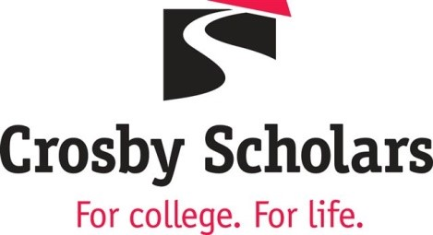

Special Events and Community Engagement Coordinator - Crosby Scholars Program

Position Information
Company | Crosby Scholars Community Partnership  2701 University Parkway  Winston-Salem, NC 27105  www.crosbyscholars.org
Working Title | Special Events and Community Engagement Coordinator
Job Category | Administrative/Professional
Position Type | Staff & Administrative
Cycle of Appointment | 12 months
Hours Worked Per Week | Full-time position
Work Schedule and Hours | Monday-Friday - some evenings and weekends required
Salary Range | Salary dependent upon experience and qualifications.
Job Summary | Reporting to the Director of Development, this position’s primary responsibilities are:  - Plan, coordinate, promote and successfully implement special events that include the Crosby Scholars Invitational Golf Tournament and Birdies and Brunch,  - Work with the development team in planning and implementing the Capital Campaign,  - Coordinate on-line giving programs,  - Serve on the grants writing and reporting team to help write and monitor grant programs,  - Review, develop and manage marketing and public relations activities,  - Prepare newsletters and publications to promote the program and its services,  - Oversee the social media intern/part-time position program assistant,  - Serve as the staff liaison to the Marketing Committee,  - Link students to community service programs and cultural events,  - Work in conjunction with staff to maintain the website and donor giving pages,  - Work to achieve goals and objectives as outlined in the Strategic Plan,  - Assist with general program activities, as needed, and  - Other duties as assigned.  The ideal candidate is a self-starter who uses data to drive informed decisions for the team.
Required Qualifications | - A four-year degree preferred but related work experience will be considered.  Strong written and oral communication skills.  Strong organizational and project management skills.  Ability to engage stakeholders and communicate the Crosby Scholars mission.  Experience in donor relations, fundraising and development.  Experience in working with donor management software.
Preferred Qualifications | Experience in working in a non-profit setting.  Managing systems.  Reviewing financial projections.  At least 5 years of community relations experience.
Desired Knowledge, Skills and Abilities | - Ability to establish and maintain effective working relationship with others.  - Ability to respond quickly and effectively to uncertainty and changing conditions.  - Ability to embrace and promote a diverse environment.  Proficient in Microsoft Office, Google Platforms and must be comfortable using emerging technologies.
Working Conditions | Must be able to do light lifting and have reliable transportation. A pre-employment background check and drug screening will be required.
To apply, submit a resume to the attention of Mona Lovett, President and CEO, Crosby Scholars Program at mwlovett@crosbyscholars.org. The review of applications will begin immediately and will continue until the position is filled.

